1.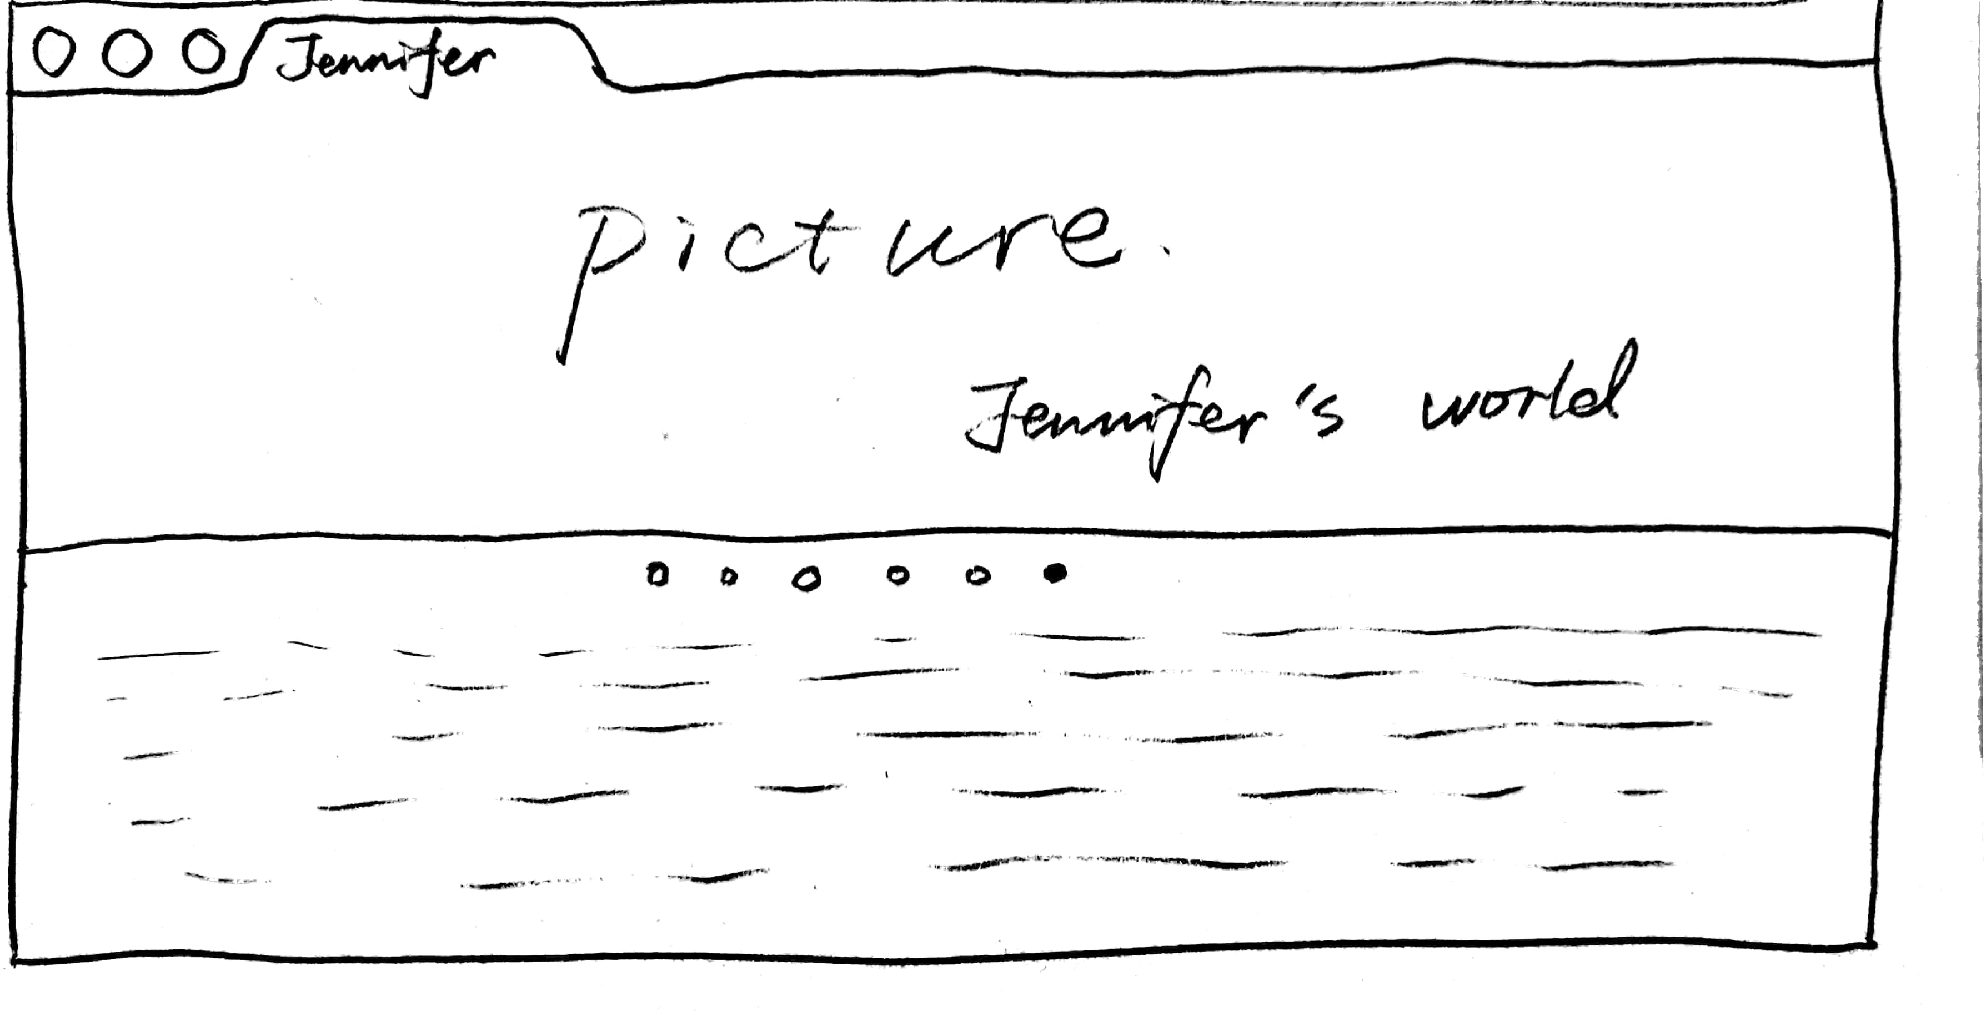

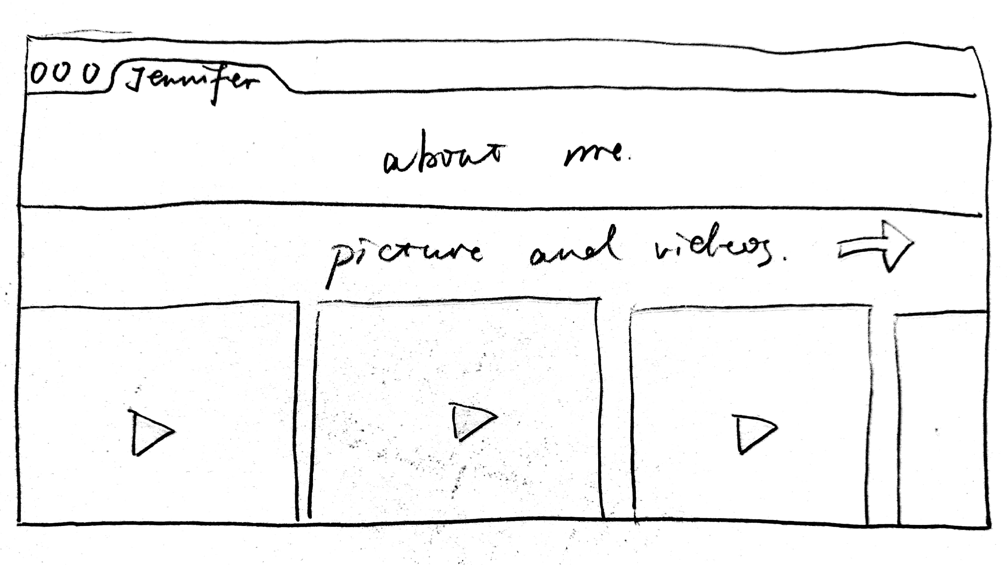

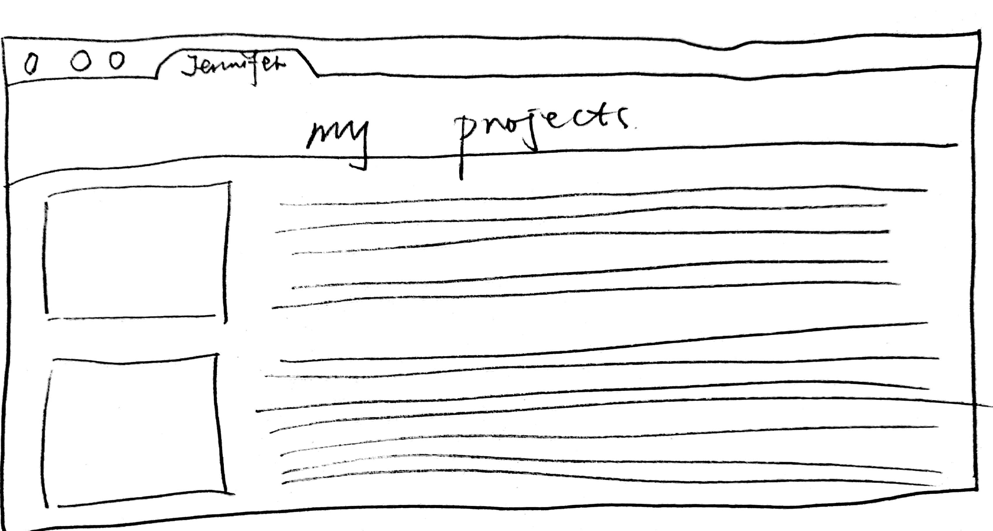

2.html元素

<p>

<a>

<h1>

<div>

<body>

<head>

<html>

<img>

<table>

<link>

<tr>

<td>

<ul>

<li>

<object>

<embed>

<button>

<center>

<canvas>

<datalist>

3.link

Article link

pictures lin

Video link

Audio link

4. The font color is black and gray, and the text content is distributed in the title, article, detailed introduction, self introduction, navigation bar and paragraph.